## Moravec Corner Detector

‘*MoravecCornerDetection ()*’ function has been called from ‘*main.m*’ file. We have derived a 3 x 3 patch for each pixel and found SSD (Sum of squared difference) in accordance with the same 3 x 3 patch in immediate top, left, right and bottom pixels. If the pixels are different then we will have a value. The highest value will be in the corners where there are changes in pixels in all the directions we are considering. We have placed a threshold of 338000 which means pixels value above 338000 in matrix ‘im_mod’ derived in the ‘MoravecCornerDetection ()’ will be considered as corners. We have placed circular marker in original image where corner exists. The result is shown below.

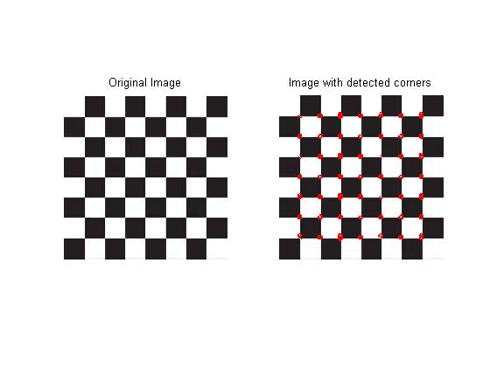

USING MORAVEC

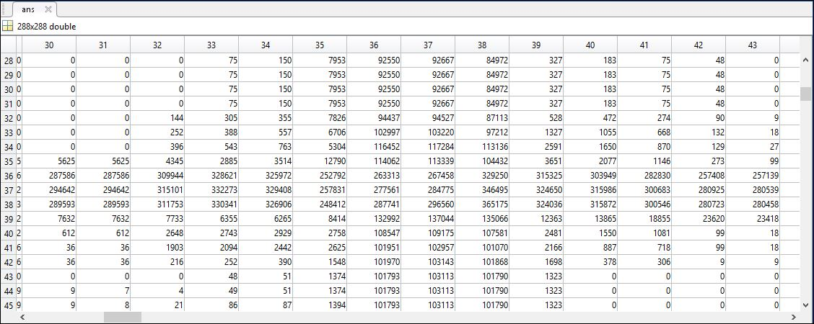

Moravec’s detected matrix on MATLAB

## Harris Corner Detector

In Harris Corner detector, we have loaded the image ‘*cb.jpg’* in variable ‘*im*’. Then the x derivative and y derivative of the image is derived using sobel mask and stored in variable ‘*ix’* and ‘*iy*’ respectively. After that, ‘*isCorner()*’ function is used to derive M matrix where,

Using ‘*eig ()*’ method we have derived the lambda values for each pixel and stored the absolute value of the difference of the two lambda values. We have put threshold where both the lambda values are high and difference of the lambda value is much smaller than places with high values where edge exists. According to threshold, we put the marker in the corner points and the output is-

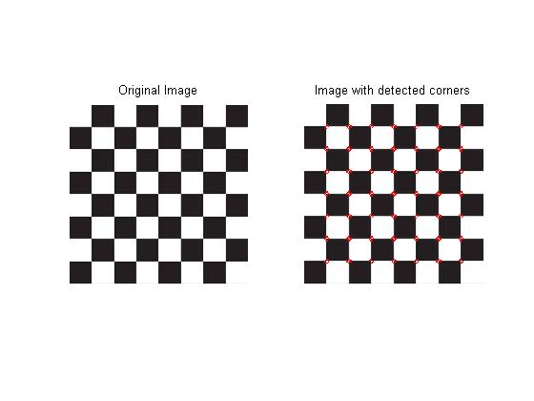

USING HARRIS

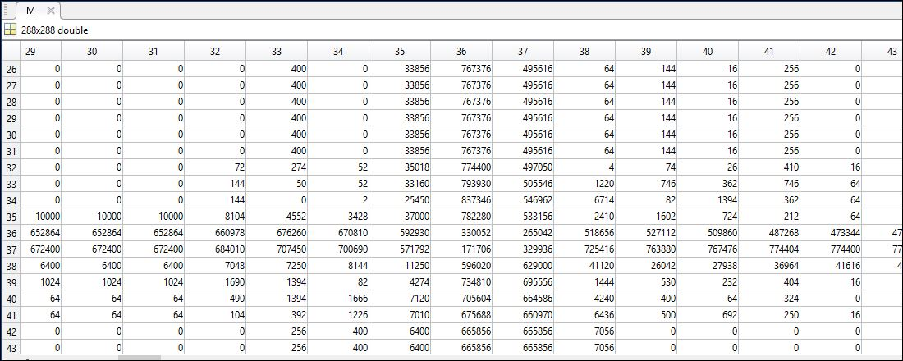

Harris’s detected matrix on MATLAB